**Reservoir continuum days** (RCD? Need a better acronym…?!):

**Overarching goal:** Assess how N, P, Chla, and DOC (quantity and quality) change over a two-reservoir gradient (from BVR inflows to FCR ouflow). The main goal is to assess changes spatially over a seasonal basis (May – September) while also capturing a gradient of hydrologic flow and oxygen conditions.

**The details:**

*Sampling time points:* designed to capture seasonal, hydrologic flow, and oxygen gradients

1. Regularly scheduled monthly sampling in: May, June, July, August, September (n = 5 samplings)
2. Adaptive sampling: have 3-4 additional samplings to capture flow and oxygen (oxic/anoxic experiment) gradients
3. 1 adaptive sampling in May (or early June): to capture the onset of anoxia (i.e., sample the reservoir continuum once FCR starts to become anoxic, but before the oxygenation system is turned on) compared to right after the oxygenation system is turned on (one of these time points would represent an ‘normal’ sampling; one time point would be ‘adaptive’)
4. 1 adaptive sampling in September – to capture a hurricane (or other multi-rain event) when residence time in the system decreases
5. 1-2 additional adaptive samplings in June-August: designed to either capture additional switches in oxygen or changes in residence time (dependent on rain fall, oxygenation experiments, how previous samplings have gone, field morale, general logistics and scheduling conflicts)

*Sampling locations:* designed to capture the full two-reservoir continuum (and the pipeline!) (total locations = 18-19)

BVR: (thanks Whitney for the maps!)

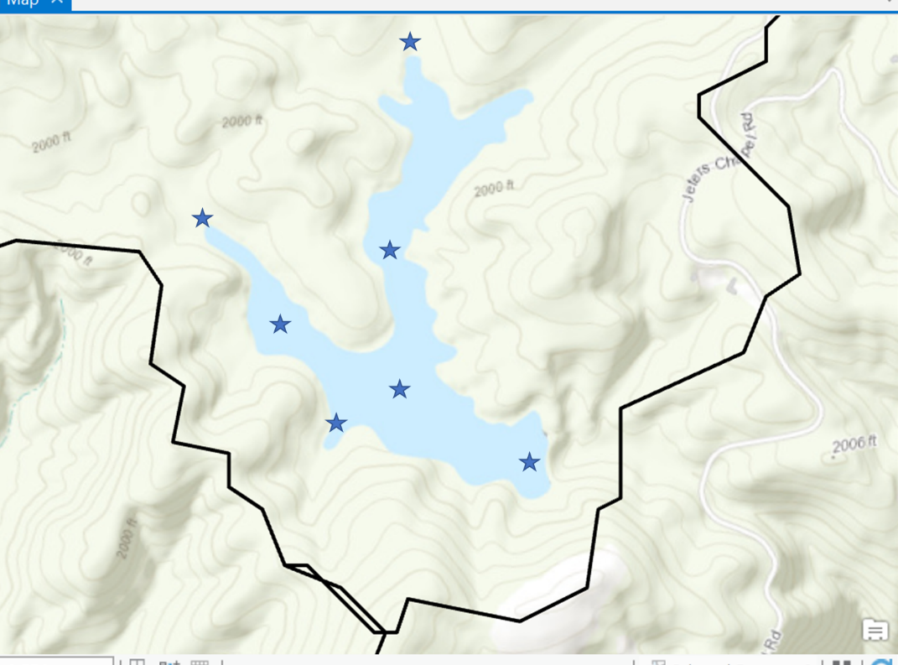

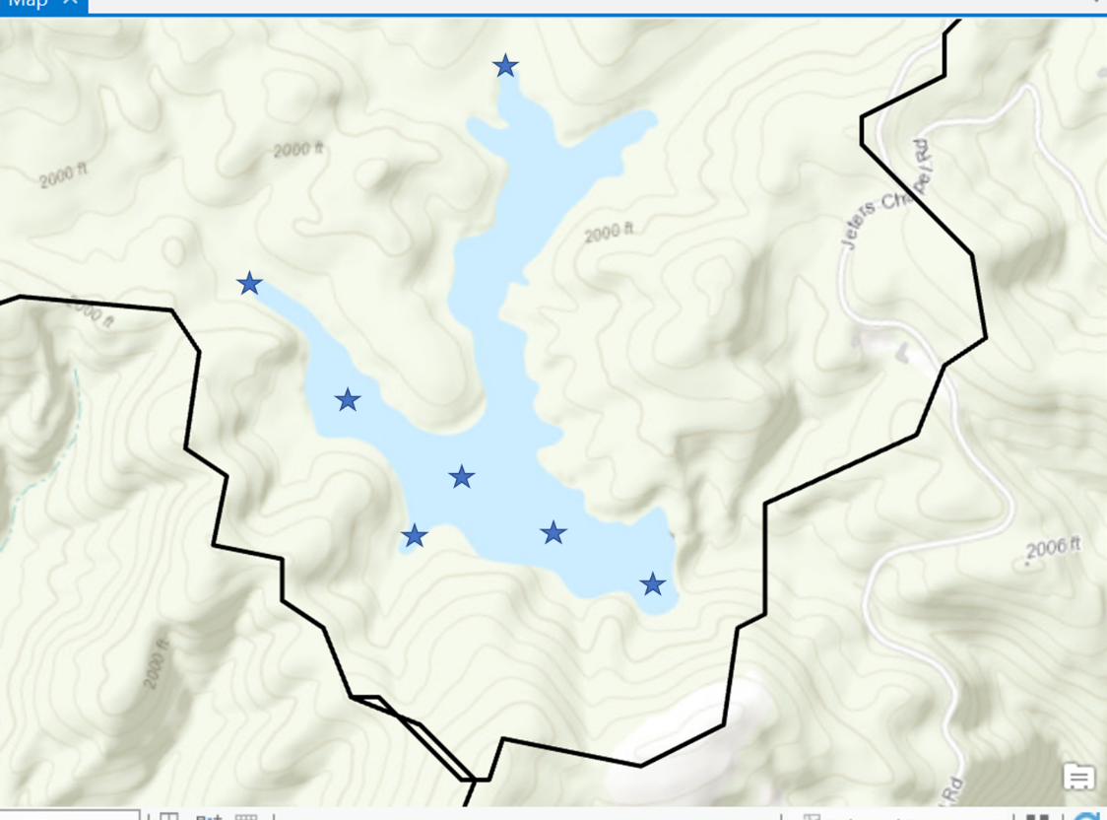

BVR highlights/location justification (n = 7 locations):

* 2 inflow sites to capture incoming C, N, P, and chl-a
* High-spatial coverage of the left arm to get an idea of spatial heterogeneity
* Most importantly, need to capture the outflow from BVR before entering the underground pipe
* And sample at existing station 50 (mainly just because/for comparisons to deep hole in FCR under changing oxygen conditions)

Stream + FCR: (again, thanks Whitney!)

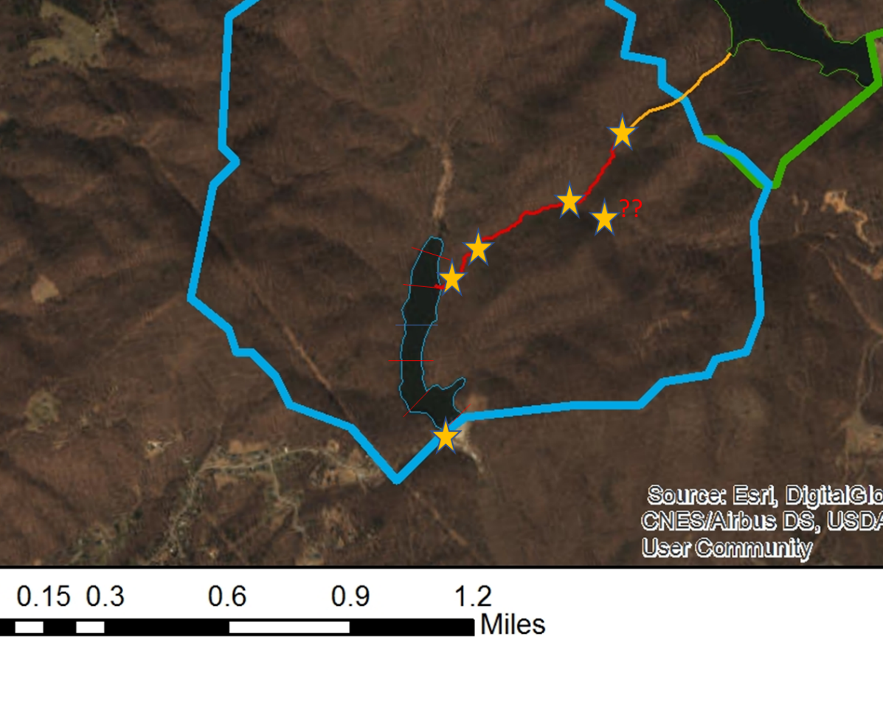

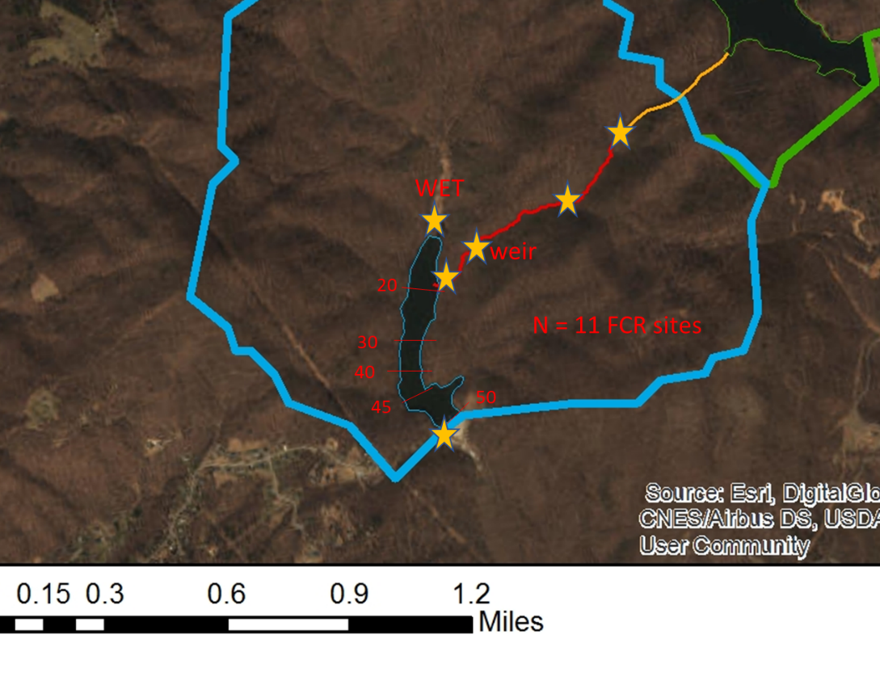

Stream + FCR highlights/location justification:

* 1. Stream (n = 5 locations)
     + Must capture outflow immediately from the closed pipe (what the heck is going on in the dark??) yes!
     + Sample at a location between the pipeline outflow and the weir
     + Sample at the weir (if we’re going to have continuous –ish discharge there anyway) = yes!
     + Sample right before the stream enters FCR
  2. FCR (n = 6-7 locations)
     + Sample wetland inflow stream
     + Sample sites 10 (?), 20, 30, 40, 45, & 50
     + Then add a sampling location for the spillway
     + Add station 25 on reservoir continuum days

*Parameters collected:* surface only (0.1 m)!

YSI cast (again, surface only!)

Total nutrients (N, P)

Dissolved nutrients (N, P, DOC)

OM quality (combusted, glass vial, filtered in field – essentially same protocol as DOC)

Filtered Chl-a

BDOC experiments (something to think about…may be good to conduct BDOC experiments on subset of time points, locations, etc.)

*Personnel and logistics:*

Have two sampling teams for each reservoir continuum day:

Team 1 (2-3 people): Sampling FCR and stream reach using small boat w/ electric motor (may be able to rent fleet car for the day?)

Team 2 (3 people): Sampling BVR using john boat

I count up to 20 sites x 10 days = 400 samples assuming you do 2 reps at each site. That’s a lot of samples! My question for you two is: what is more important, fewer sites but more days or more sites but fewer days? (space vs time, the eternal tradeoff…)

WW: as my questions are developing, I think I’m more interested in higher spatial coverage but fewer days. With the changes I am proposing right now, there are 5 within-reservoir sites in BVR and FCR, 2 inflows to both BVR (left and right arm) and FCR (wetland and stream), and one outflow for each reservoir (at the pipe in BVR and at the spillway in FCR). Then we have high spatial coverage of the weir’d stream between BVR and FCR. I like having the synchronicity between sites for the two reservoirs, but am definitely open for suggestions for moving the sites around more.

So the total number of sites as proposed now is n = 18. 18*5 monthly samplings = 90 + 18*3 (1 in May, 1 in September, and 1 in June-Aug) adaptive samplings = 54, so 144. If we do an extra rep of each that is 288 total nutrient/carbon samples to be run. What are everyone’s thoughts?

AGH: I think this seems reasonable – a trade off in terms of location and sampling frequency. Would it be possible to remove the sited between 50 and the confluence in BVR? Or do you want to keep this to maintain the number of samples in each reservoir? In terms of temporal sampling, we *might* even be able to get away with having only 2 adaptive samplings (especially if capturing oxygen dynamics is less of an concern – since this should be heavily sampling during the ‘regular’ sampling events) and if we can capture a range of hydrologic flow conditions with the other samplings (may have to wait and see….). But I do agree with Whitney that a good representation of what is happening spatially in BVR would be important (as this is one of the great unknowns!).

At a bare minimum, I think that you could go down to 5 sites at BVR (2 stream inflows, mid-left arm, 50, outflow to FCR) and then 10 sites in (pipe outlet, mid-stream, weir, stream entering FCR, wetland/10, 20, 30, 45, 50, spillway) = 15 sites. That would only result in 300 samples, which would save you many days in the lab. Something for you two to consider?